Database Evaluator Tool  
for SQL Server Databases

|  |  |  |  |
| --- | --- | --- | --- |
| Hardik Kansara  Student  hardik.kansara001@student.weltec.ac.nz | Changming Wu  Student  changmin.wu001@student.weltec.ac.nz | Kwinno Pineda  Student  kwinno.pineda001@student.weltec.ac.nz | Patrick Cura  Student  patrick.cura001@student.weltec.ac.nz |

Steve McKinlay

(Adviser)

steve.mckinlay@weltec.ac.nz

ABSTRACT

The Database Evaluator Project was designed for small to medium companies who do not have that much funds to hire a full time administrator to evaluate the integrity of their SQL Server Databases. It is composed of a: a) Client Application that produces a file containing information about the user’s SQL Server parameters, b) Product Website where the file generated by the Client Application is uploaded for evaluation, c) Database Evaluator which produces an evaluation report from the user’s parameter file.

**Keywords**: SQL Server, Microsoft, Databases, Instances, Database Administration

# Overview

Secure and efficient database implementation following best practice is one of the challenges for organizations and database administrators. Also, evaluating SQL Server configurations is a time consuming process and involves a lot of manual labor. Furthermore, it is very difficult for database administrators to check and create an inventory of all database parameters especially for large environments.

With the stated challenges, the group created a database evaluator tool that diagnoses and checks the basic implementation parameters of SQL Server Instances and Databases. The product created is targeted for SQL Server Versions 2008 and 2012.

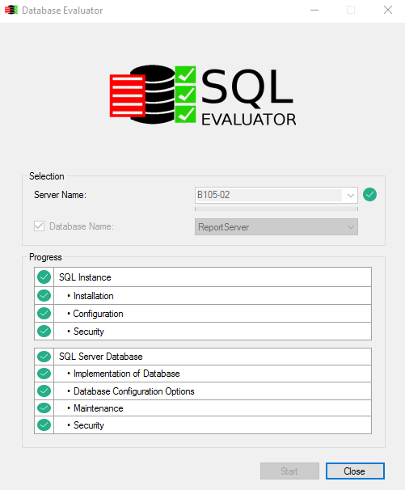

**Fig 1 Client Application of our Database Evaluator Project**

The project involved the creation of 3 applications working hand in hand to deliver a SQL Server Evaluation report to the user.

The first one is the Client Application that gathers all the SQL Parameters from a SQL Server instance chosen by the user. The data gathered is put into a dump file which is encrypted for security purposes.

The next application is the Product Website. This is where a user can upload the dump files produced by the Client Application.

The third application is the Database Evaluator itself which the Project Team runs to do the evaluation for them. This application decrypts the dump file and produces an evaluation report based on the parameter values in the dump file.

The team followed the DSDM methodology to build the project to completion. It first involved looking into the tool requirements and estimating if the project can be completed on time. Then after planning, the applications involved were developed through a number of iterations. In the final phases, the applications were comprehensively tested by the Test Manager and all bugs were logged and fixed.

In the end, all three proposed applications were successfully created. The Product Website is publicly available online (<http://sqlstriker.com/>). The Client Application is downloadable from here and people can try it out for themselves.

# Title

**Database Evaluator Tool for SQL Server Databases**

# Authors

The project team consisted of four students completing their final capstone project as part of their Level 7 Graduate Diploma in Information Technology.